BANK Database – DQL & DML Tasks
DQL
- Display all customer records.
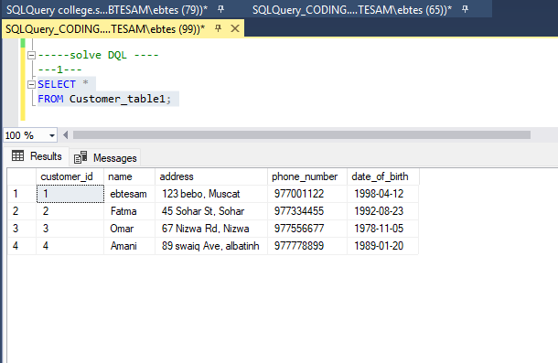
2. Display customer full name, phone, and membership start date.
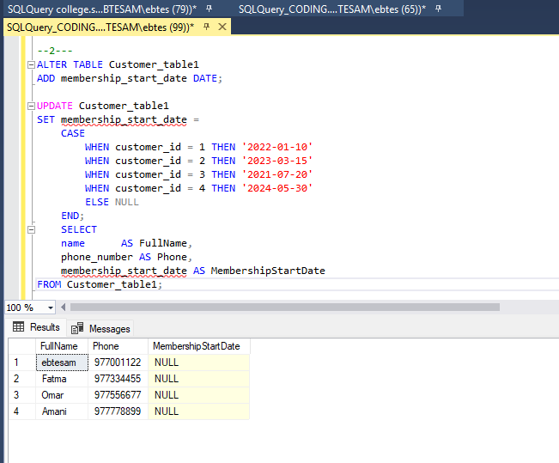

3. Display each loan ID, amount, and type.
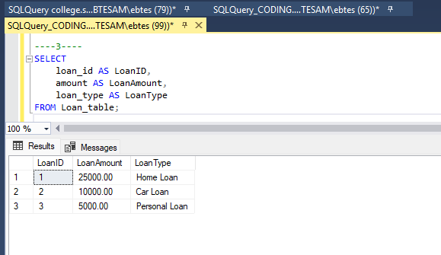
4. Display account number and annual interest (5% of balance) as AnnualInterest.
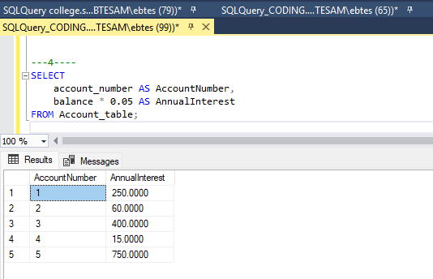

5. List customers with loan amounts greater than 100000 LE.
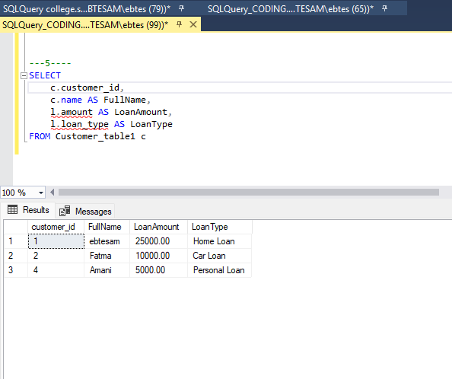
6. List accounts with balances above 20000.
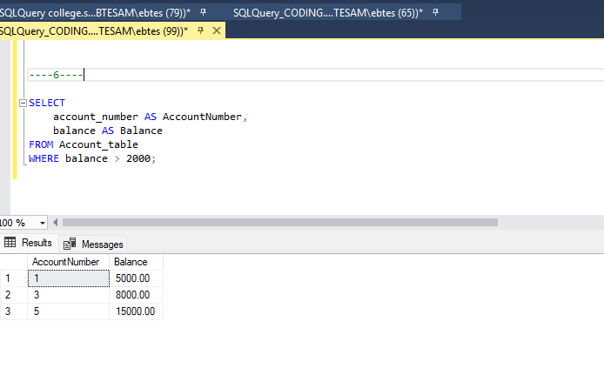

- Display accounts opened in 2023.
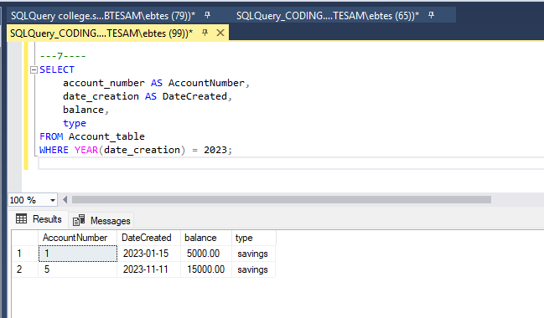
8. Display accounts ordered by balance descending.
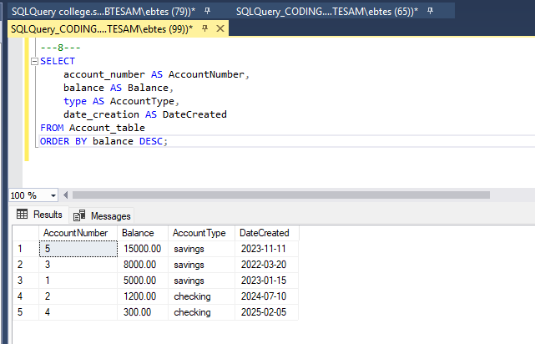

9. Display the maximum, minimum, and average account balance.
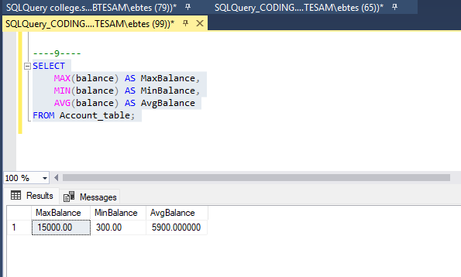
10. Display total number of customers.
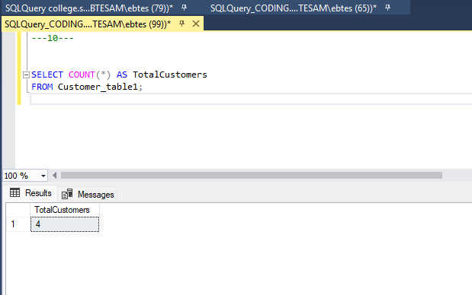

11. Display customers with NULL phone numbers.
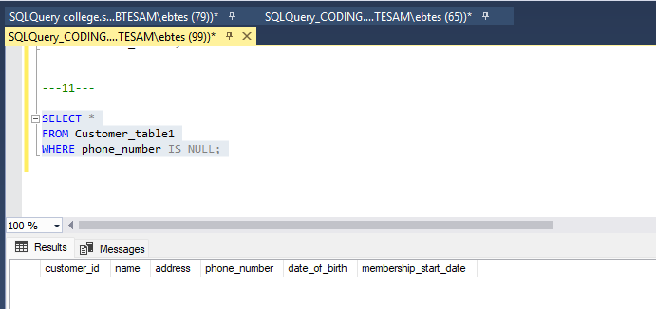
12. Display loans with duration greater than 10 years.

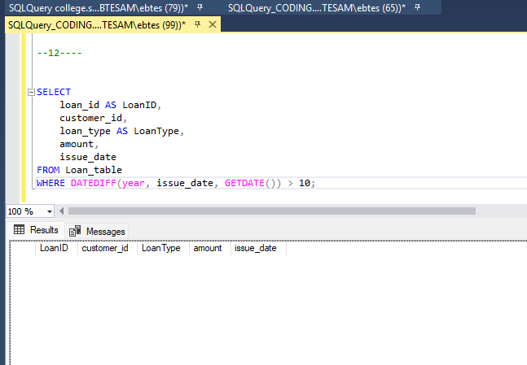

DML
13. Insert yourself as a new customer and open an account with balance 10000.
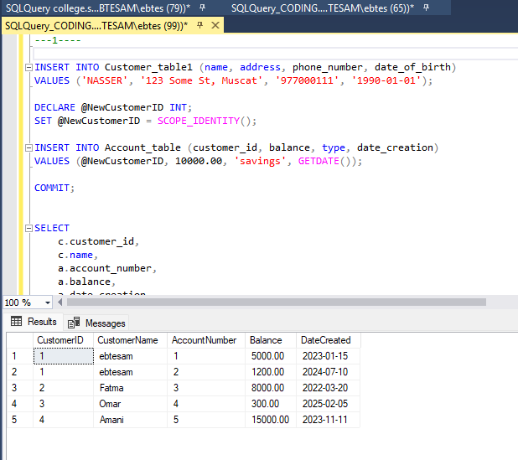

14. Insert another customer with NULL phone and address.
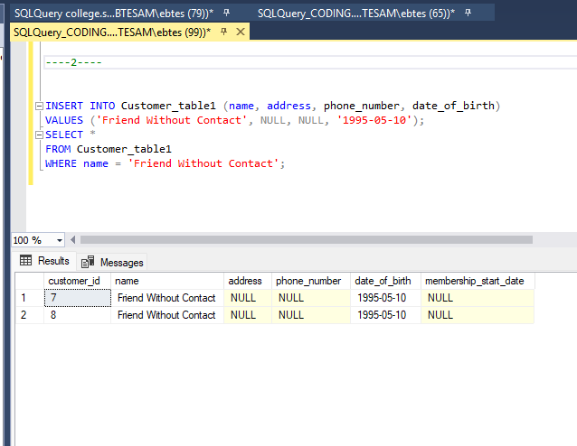

\

15. Increase your account balance by 20%.
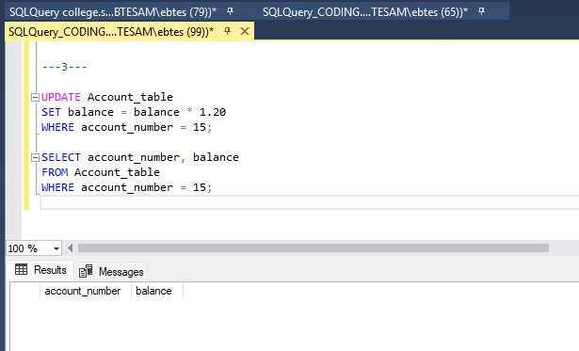
16. Increase balance by 5% for accounts with balance less than 5000.
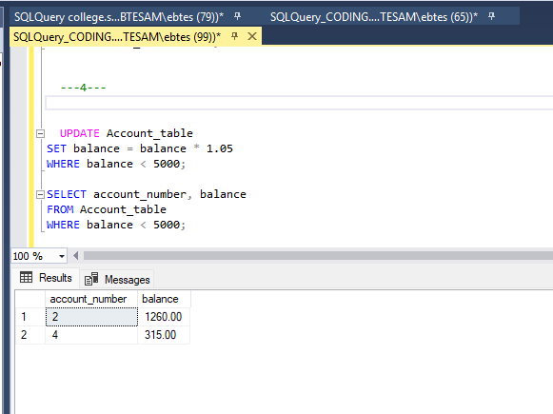

17. Update phone number to 'Not Provided' where phone is NULL.
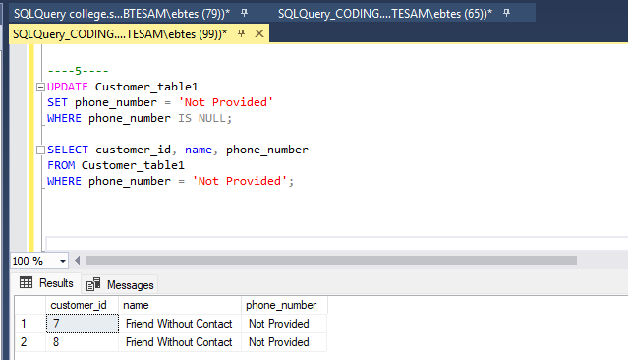
18. Delete closed accounts.
